A000-Afr-D R Congo-Luba, Hemba, Double Caryatid Stool with Male and Female Figures-Mid 19th c

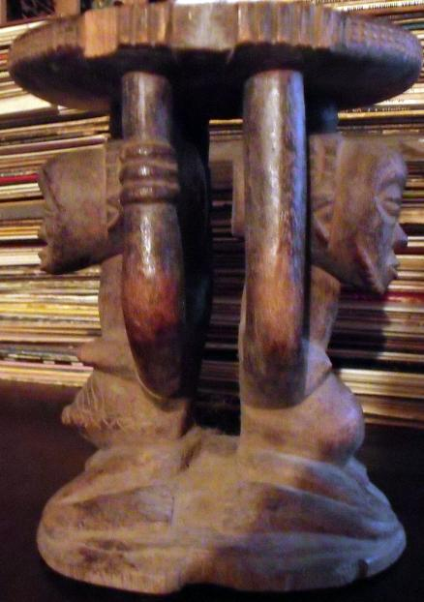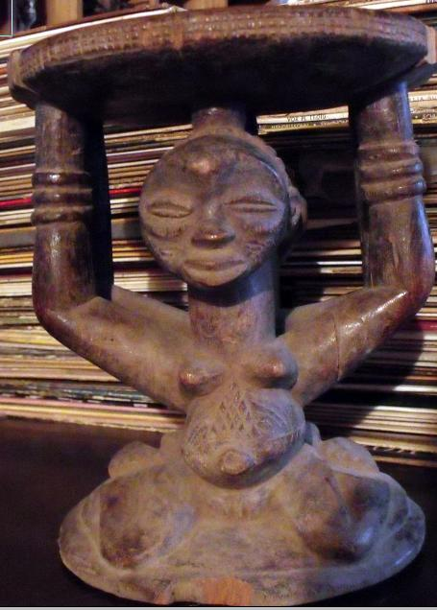

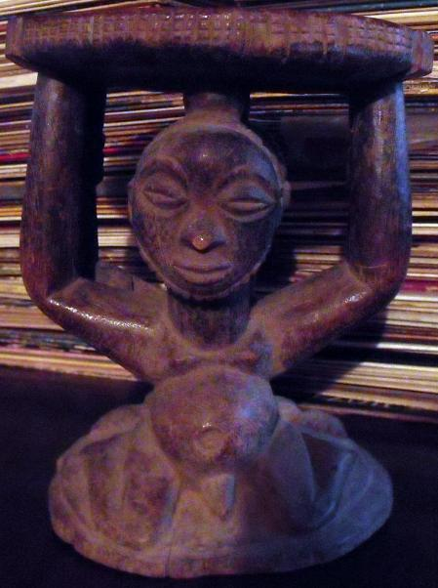

Figs. 1-3. Afr-D R Congo-Luba, Hemba, Double Caryatid Stool with Male and Female Figures-Mid 19th Century

Case No.: 6

**Accession No.**

**Formal Label:** Afr-D R Congo-Luba, Hemba, Double Caryatid Stool with Male and Female Figures-Mid 19th Century

**Display Description:**

The Luba, a Bantu-speaking people, are one of the oldest recorded tribes in central, equatorial Africa. By the ninth century CE they had expanded their empire throughout the region. The Luba developed a governance network with a central ruler who succeeded through the mother's line. Since the Luba venerate women, their art reflects this. This Caryatid stool depicts a chieftain and his mother commemorating the dual ancestral rule of these two individuals and would have been used by a chieftain. When not in use Luba stools were kept on ritual altars, wrapped in linen or cotton cloth and were only visible for ritual gatherings. This stool is very rare since the surfaces of the seat and the figures display a high patina indicating that it was in active use for generations

**LC Classification:**

**Date or Time Horizon:** Mid 19th Century

**Geographical Area:**

**Map:**

**GPS coordinates:**

**Cultural Affiliation:**

**Media:**

**Dimensions:**

**Weight:**

**Condition:**

**Provenance:** A similar caryatid stool (depicted at the right) with a similar patina sold in 2004 for $18,000 by the Titus Gallery, 222 The Commons  
Ithaca, NY, having the following data: A rare Hemba/Luba double figure caryatid stool. The fine, varied, dark patina and wear is consistent with many years of use. Origin:  Zaire; Height:  16.75 inches; Provenance:  Stuart J. Warkow, SMA Fathers Missionary Museum, Titus Gallery. $18,000.

**Discussion:**

Much more is known about the Luba than many of the other tribes on the African continent due to the way that they used intricate works of art called "lukasa" and other memory devices to record their history. The lukasa is a bead and shell-covered wooden "memory board" that embodies fundamental precepts about Luba kingship. This book recounts the history of the Luba and their culture to the present day and demonstrates the varying ways in which early Luban art is used to memorize the complex structure of sovereign rule within their empire. The book illustrates more than 100 important Luba works in museums and private collections around the world. These illustrations feature royal emblems, including thrones, sceptres and lukasa, dating from the 18th to the early 20th century and bearing patterns, figures and motifs which served, as they do now, as vehicles of historical thought and ideology for the Luba people. Photographs from the 1980s and early archival photographs from the turn of the century show the works in their contexts of royal investitures, divination rites, and secret association dances. Many of the works of art in this publication are accompanied by the narratives of contemporary Luban people, to show how the works help to illicit memory and how memory is a dynamic, creative process.

**References:**

M. N. Nooter and A. F. Roberts, *Memory, Luba Art and the Making of History*. Munich: Prestel, 1996; http://www.titusgallery.com/africanart.html.

